Nitrogen, Key Ingredient for Life
A person needs roughly 8 grams of nitrogen a day.
That’s about 6 liters (imagine 3 2-liter bottles) of nitrogen (N₂) gas per day.
But you can’t get your nitrogen from the air.
You have to get it from protein-rich food. And the protein in your food is only about 16% nitrogen.
And it’s not just necessary to get enough protein. You need to consume certain kinds of protein, containing the necessary amino acids.
Amino acids are the building blocks of proteins.  Glycine (shown) is the simplest amino acid. | 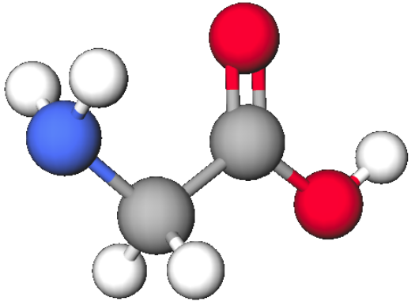
Of the 21 amino acids common to all life forms, there are 9 amino acids humans cannot synthesize (phenylalanine, valine, threonine, tryptophan, methionine, leucine, isoleucine, lysine, and histidine). Three more (cysteine, tyrosine, and arginine) are required by infants and growing children.
Affects of a deficiency of an essential amino acid can include impairment of brain function, immune system, and digestion; also symptoms of nervousness, exhaustion, and dizziness.
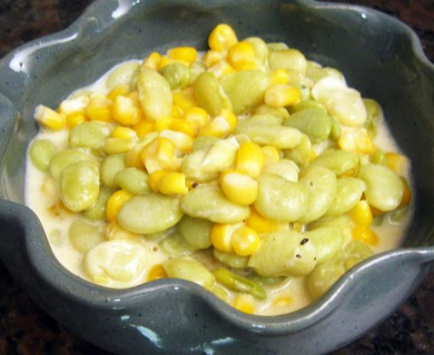 | Succotash (from Narragansett sohquttahhash) is a Native American recipe combining corn and beans. This was probably more than just a matter of taste. Corn (maize) is deficient in lysine and tryptophan but has fair amounts of methionine and cystine. Beans are a relatively rich source of lysine and tryptophan but are low in methionine and cystine. By combining the two ingredients all essential amino acids are supplied.

